CitraFiber® Fact Sheet
For Confections and Treats
All-Natural Up-Cycled
CitraFiber® is a great all-natural emulsifier making it an efficient carrier of flavors and reduces the use of sugars and other sweeteners.
CitraFiber® is very lipophilic making it the smart ingredient to increase moisture retention and even increase yields in many applications.
CitraFiber® is uniquely functional, high in Pectin and total dietary fiber making it the all-natural choice for replacing gums and other non-natural ingredients.
CitraFiber® is higher in pectin and total dietary fiber than other citrus fibers on the market, making it the cost-effective choice for all types of confection formulations.
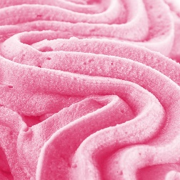
CitraFiber® is colorless and odorless and tasteless in formulation/application.

